Navigate to the reporting module, and click Dynamic Reports

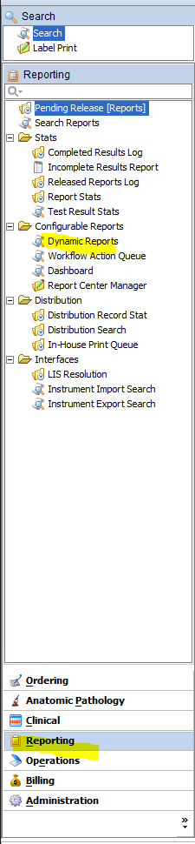

Select the dynamic report “Synotpic” and change the created date to last quarter and the diagnosis grade to Malignant. Click F1 to run report.   
  
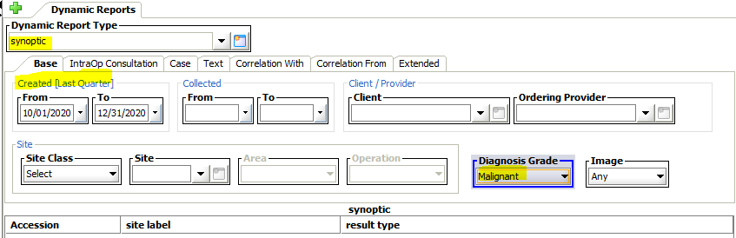

Right click on the data and save to Summit Pathology One Drive Company

IT-General->Projects->synoptic-reporting->data  
File name: yyyy-q?-synoptic-raw.xls